GAME IDEA 1: Game Design Brief
Concept:
Target Practice, a simple shooter .game with targets further and further back with point values assigned to them based on where they are.
Gameplay:
the player spawns in a confined area (shooting Range) with a rifle thety are instructed to “ADS” and fire, after all targets are destroyed they reset.
Core Mechanics:
aim down sights
firing mechanics
reload function
interactive target
point score
time
Minor Mechanics/Logic:
pause
alternate targets
moving Targets
movement system
Out of scope mechanics:
bullet ballistics
crouching / laying
reload animation
Inspirations/similar works:
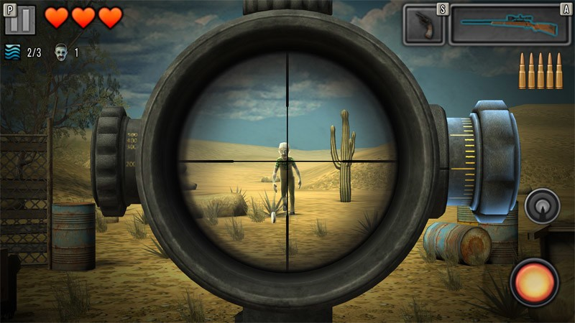
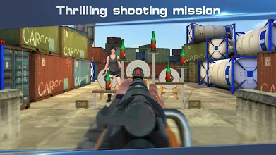

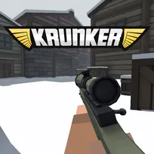

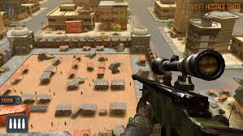
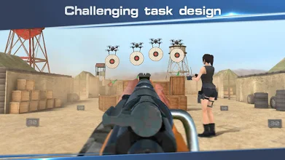

Development challenges:
bullet ballistics and ADS are two things that I am worried about
interactive targets are also a worry but less so

